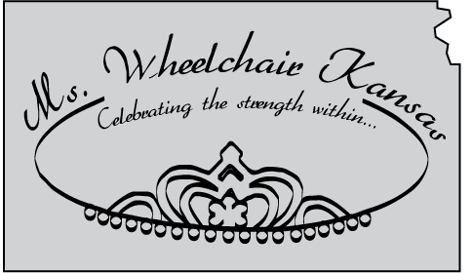 | Ms. Wheelchair Kansas  Changing Attitudes  Creating Opportunities

The Ms. Wheelchair Kansas organization supports strong, spirited women who are wheelchair mobile. Won’t you support our efforts to build a platform of opportunity for these accomplished women to share their stories? To partner with our program is to provide amazing opportunities and acknowledge the possibility inside each and every one of us. ALL partners will be acknowledged during the Crowning Event and on our MWKS Facebook Page. Additional benefits of partnership include:

DIAMOND LEVEL (Gifts at, or above, $2,000): Complimentary Titleholder Appearance, YOUR logo on Event T-Shirts, Outreach Materials and the MWKS Website, Recognition via Signage during Event, Complimentary Exhibitor Space during Crowning, and a Full Page Ad in Crowning Program.

PLATINUM LEVEL (Gifts between $1,500 and $1,999): YOUR logo on all Outreach Materials and the MWKS Website, Recognition via Signage during Event, Complimentary Exhibitor Space during Crowning, and a Full Page Ad in Crowning Program.

GOLD LEVEL (Gifts between $1,000 and $1,499): Complimentary Exhibitor Space during Crowning, a Full Page Ad in Crowning Program and YOUR logo on the MWKS Website.

SILVER LEVEL (Gifts between $500 and $999): YOUR logo on the MWKS Website and a Half Page Ad in Crowning Program.

BRONZE LEVEL (Gifts between $100 and $499): A Half Page Ad in Crowning Program.

Celebrate the strength within! Complete this form and become a partner with the Ms. Wheelchair Kansas program TODAY! For more information, contact Carrie Greenwood, Coordinator, at 785-633-7255 or mswheelchairkansas@yahoo.com.

BUSINESS or ORGANIZATION NAME & ADDRESS: _________________________________
_______________________________________________________________________________
Contact Person: __________________ Phone: (_____) __________ Email: __________________________
Amount Enclosed: ______________ (Kindly make checks payable to Ms. Wheelchair Kansas)

Please send completed form, along with your generous contribution and ad, to:
Ms. Wheelchair Kansas
4413 SE Minnesota Ave.
Topeka, KS 66609

