  FOR IMMEDIATE RELEASE  March 30, 2024 | Contact: Carrie Greenwood, President/CEO  (785) 633-7255 Phone  mswheelchairkansas@yahoo.com  www.mswheelchairkansas.org

NEW MS. WHEELCHAIR KANSAS AND LITTLE MISS CROWNED
New titleholders to empower and educate Kansans in the coming year

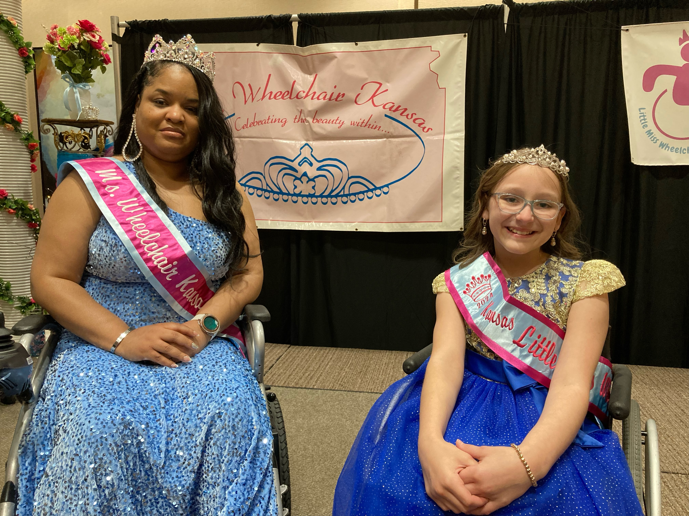
The 2024 Ms. Wheelchair Kansas (MWKS) was recently crowned during a weekend ceremony held March 24, 2024, at the DoubleTree Hotel in Lawrence, Kan. Tamara Blackwell of Bel Aire received her crown after participating in four judging sessions, as well as many other activities, throughout the three-day event held March 22-24. The weekend concluded with a formal crowning, where Tamara was chosen as the new titleholder and fellow contestant Bridget King, of Topeka, was chosen as the runner-up. The ninth Little Miss Wheelchair Kansas was announced at the ceremony as well. Josie Metzinger of Geuda Springs will work alongside Tamara in the coming year to empower Kansans with her title.

The crowning ceremony was attended by more than 100 family, friends, and community members. The event consisted of platform speeches by the two contestants, as well as two on-stage questions. The audience enjoyed a slide show of memories from the weekend; a keynote speech from Ms. Wheelchair America Vice-President and Long Beach, CA City Councilwoman, Mary Zendejas; and a farewell from the 2023 MWKS titleholder, Daija Coleman of Atchison, and Little Miss, Olivia Woodard of Goddard.

Tamara, the new titleholder, wants to shed light on the challenges of people with disabilities, but also show the beauty in the life of a person with a disability. Tamara herself has a full and active life. She is a wife, a mom of three kids, and lives in Bel Aire. Tamara, who has Muscular Dystrophy, does not let her disability stop her from anything. She holds a degree in Early Childhood Education from Walden University. Tamara has been an Early Childhood Educator since 2007 and has had her own business, called Tammy's Tots Home Daycare LLC, since 2010. She works as a Youth Director with her church and assists with the church outreach ministry. Tamara wants to educate and inspire people with and without disabilities. She wants to show the world HER world. She already does this by utilizing social media platforms to make people aware of important issues and show the realities of living with a disability. Tamara wants to be an advocate for change, while also encouraging those like her to never give up!

Josie, the new Little Miss, is an 11-year-old fifth grader from Geuda Springs who attends school at South Haven Elementary. She has had spina bifida since birth and, despite the challenges she faces navigating life in a wheelchair, Josie is resilient, determined, and has a radiant spirit. She is an advocate for inclusivity and has the ability to spread joy with her infectious smile. Josie is an athlete with Wichita Adaptive Sports, makes cards to send to people in need through Operation Gratitude, and collects pop tabs to donate to Ronald McDonald charities.

Tamara and Josie will serve as role models and spokespersons for people with disabilities in Kansas in the coming year. They will strive to educate, advocate, and empower all people in our state. They will have the opportunity to travel throughout Kansas educating various groups of all ages about the issues of importance to people with disabilities. Tamara will share her platform of “Advocacy for the Community,” which emphasizes the importance of accessibility and inclusion in all aspects of life. Tamara will also ultimately represent Kansas in the Ms. Wheelchair America competition, held in Grand Rapids, MI in August, where she will compete for the national title alongside 23 other women from varying states. Josie will work alongside Tamara to show the capabilities of people with disabilities. She will empower people of all ages, especially young people in our state.

To schedule an appearance or presentation by the new Ms. Wheelchair Kansas or Little Miss Wheelchair Kansas, contact Carrie Greenwood, President/CEO, at (785) 633-7255 or via email at mswheelchairkansas@yahoo.com. More information can also be found on the Ms. Wheelchair Kansas web site at www.mswheelchairkansas.org.

Ms. Wheelchair Kansas, Inc. is sponsored in part by
the Prairie Band Potawatomi Nation, The Whole Person, and Advisor’s Excel.

